**TCTD CHALLENGE**

**IIT DHARWAD**

**Introduction:**

Transplanting is the most common and elaborative method of crop establishment for rice in Asia. Rice seedlings grown in a nursery are pulled and transplanted into puddled and leveled fields 15-40 days after seeding (DAS). Transplanting ensures a uniform plant stand and gives the rice crop a head start over emerging weeds. Further, seedlings are established even if the field is not leveled adequately and has variable water levels. Rice seedlings can either be transplanted manually or by machine.

**Identifying the problem:**

In India, the manual transplanting method is more prevalent mainly due to the small size of land holdings and lack of technological infrastructure.

* Manual rice transplanting is a labor intensive, tedious and time consuming process.
* The cost of existing transplanting machines is way above the overall income of an average farmer.
* It is difficult to maintain optimum spacing and uniform plant density, especially with random transplanting and contract labor which leads to low crop yields.

**Existing Solutions:**

There are a variety of machines which are already being used to mechanize rice transplantation. Examples of such machines are:

* **PADDY PANTHER:** It works on double rocker mechanism. It has precise control over plant population and hill spacing according to variety of rice. A maximum of 27 seedlings/m2 can be transplanted. The cost being around Rs.3.15 lakhs.
* **MAHINDRA MP-46:** The Rice Transplanter MP-46 is equipped with a 5 HP motor, rubber lugged wheels, and easy, accessible controls, to make planting rice an effortless process for farmers. The automatic float adjustment mechanism ensures uniform depth in planting. The cost being Rs.1.9 lakhs.

The two machines mentioned above, while extremely efficient, are not suitable for smaller farms which are mainly found in India. Though these machines reduce man power, they are prohibitively expensive and not feasible for the average farmer.

**Field Survey:**

Paddy transplanter’s sales are highly dependent on land holdings and the economic condition of the farmers. There is increasing demand every year from major paddy cultivating regions across the country for these machines. We conducted a survey to gauge the awareness of farmers towards rice transplanters. Among the 20 total respondents 75% of the respondents were aware of paddy transplanters while 25% of the respondents said that they have never heard about paddy transplanters, which shows that a good percentage of farmers have awareness about these machines. We then proceeded to ask the farmers who were aware of rice transplanters whether they themselves used these machines. 80% of these farmers replied that they did not currently use rice transplanters. On being asked the reason, most of them replied that the cost was too high for them. We also noticed that the size of the fields ranged from 1.08 hectares to 1.15 hectares.

**Business Case Analysis:**

In the present situation in India, most of the agricultural machinery in India is imported from abroad, mainly Japan. This causes prices to shoot up tremendously, moreover replacement parts/spares are not manufactured in India and have to be imported leading to delays and higher costs. A refurbished, moderate condition transplanting arm of a reputable company costs about 73,000 rupees.

Manual rice transplanters are hard to use and involve some labor cost, whereas fuel based transplanters cost a lot to maintain and use.

Hence a moderate sized electric rice transplanter which costs less, is made in India and easily serviceable is required. The existing products have a complicated transplanting mechanism comprising of various moving parts, hence having more tendency to break down. Our solution has only a few moving parts and is thus more robust than existing solutions.

**Our Objectives:**

We intend to create a machine which can be used to transplant rice on smaller farms, a demographic that is often overlooked. Keeping in mind the financial conditions of most of the small scale farmers, we plan to keep the cost of our device as low as possible. We also aim to keep our transplanting mechanism simple and robust so that it can be easily repaired by even an amateur mechanic.

**Understanding The Process:**

1. The seedlings are transplanted after they are 15 to 40 days old.
2. The size of the seedlings varies from 8 to 25 cm.
3. They are transplanted in a flooded field (of an average depth 10 cm) at an optimum spacing of 20 cm x 20 cm.
4. The planting depth is 3-4 cm.

**Our Solution:**

Our prototype is an electrically powered rice transplanter which is capable of transplanting a single row of rice seedlings in a straight line.

**Design and Engineering Details:**

The main requirement of our device is to pick up rice seedlings from a movable tray and push them in the soil. We achieved this by means of an assembly using a crank rocker mechanism with a fork attached in front of it. For pushing the seedling into the ground we are using a cam and spring based piston mechanism. The schematic of both mechanisms are shown below.

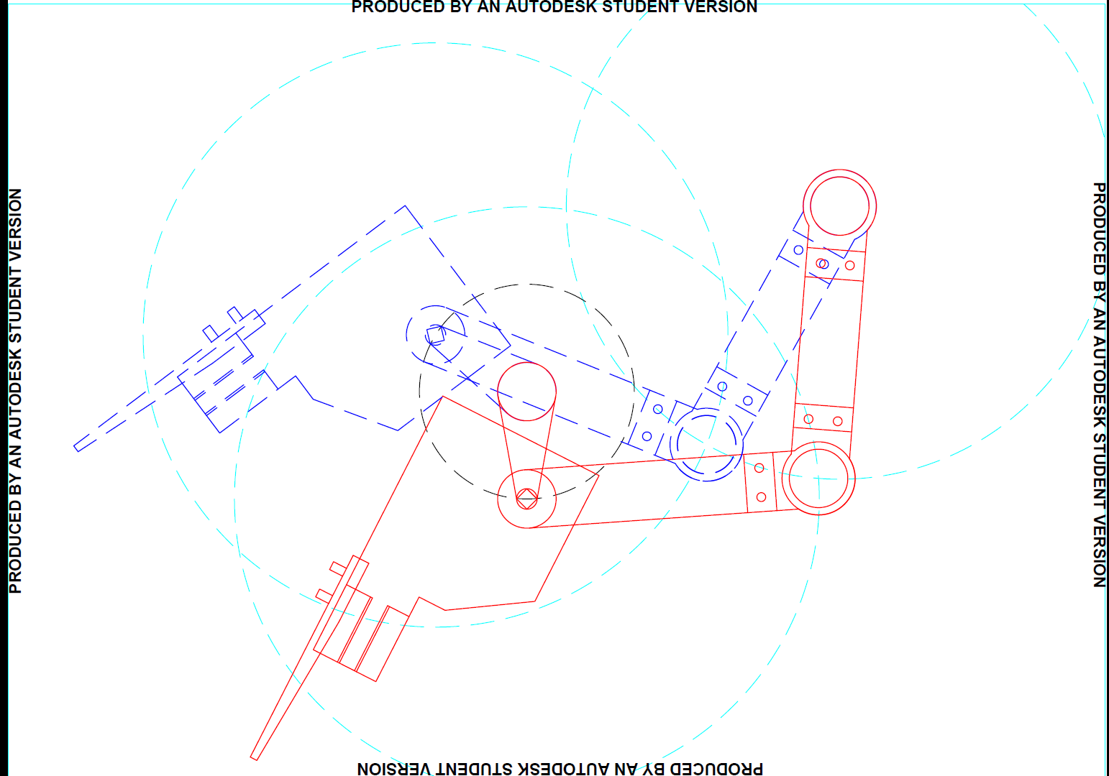

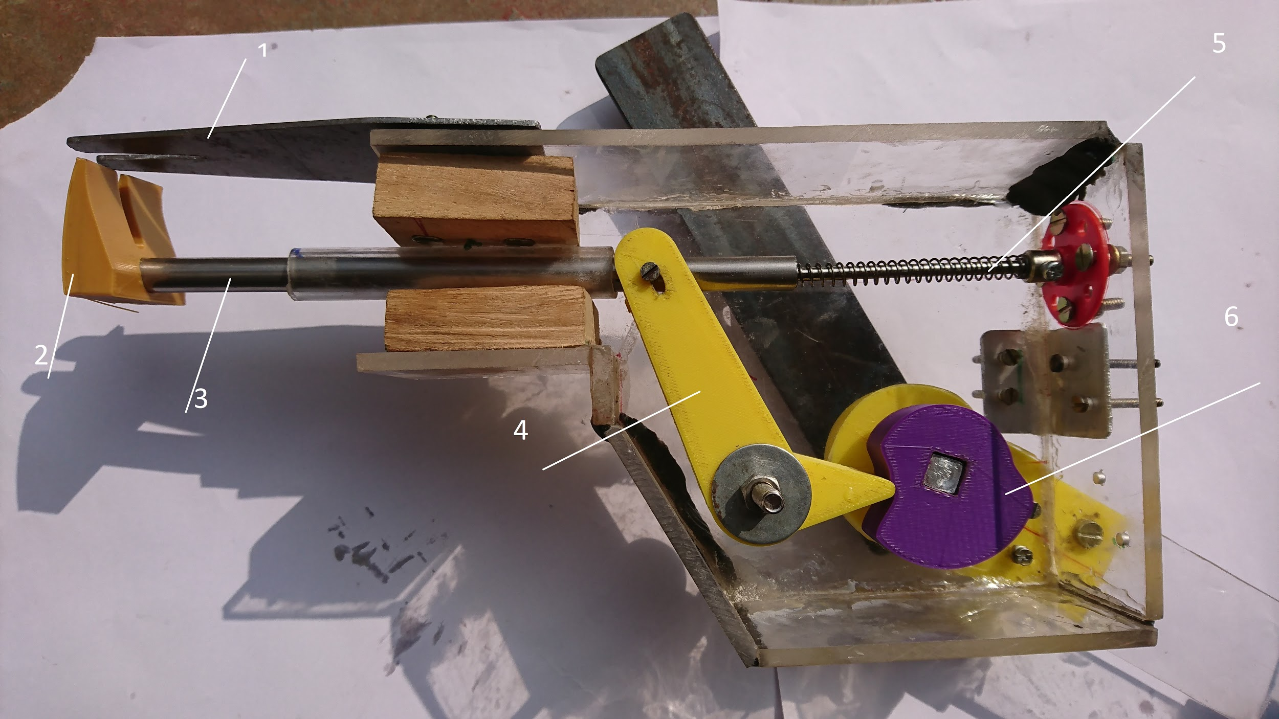

1: Picking Fork, 2: Pushing Fork, 3: Piston, 4: L-Fork, 5: Spring, 6: Cam

The transplanting arm consists of three acrylic pieces connected with 3D printed elbow joints. The rear arm is fixed on a mount which is further connected to the body. The front arm is connected to the gearbox with the help of an aluminum flange. The cam is solidly attached to the middle arm. The L-fork acts on it at one end. The other end of the fork makes to piston rod move linearly relative to

the arm shell with the help of a spring. When picking the seedling, the cam pushes one

end of the L-fork and the L-fork comes contact with the cam’s bigger radius.

This pulls back the piston on the other end of the L-fork. At this stage the

fork in the front of the arm shell clamps the seedling between its

arms. When planting the seedling, the spring pushes out the piston which in turn pushes out the seedling trapped in the fork into the soil completing the planting operation. Subsequently,

the fork resets under the action of the spring and is ready for the next seedling

operation.

The inclined tray can move along a rail perpendicular to the direction of motion of the transplanter to enable the transplanting mechanism to pick up a new seedling with each rotation. This motion is achieved by using a stepper motor in conjunction with a lead screw.

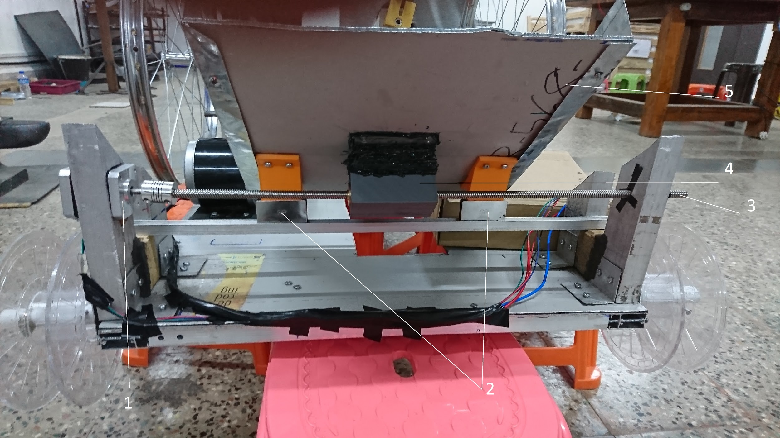

1: NEMA 17 Stepper Motor, 2: Rails, 3: Lead Screw, 4: Tray Support, 5: Tray

The power from the motor is divided between the rear wheels and transplanting mechanism by means of a gearbox. Power is transferred from the motor to the gearbox and the gearbox to the rear axle by means of chains. The transplanting mechanism directly receives power from the shaft of the gearbox.

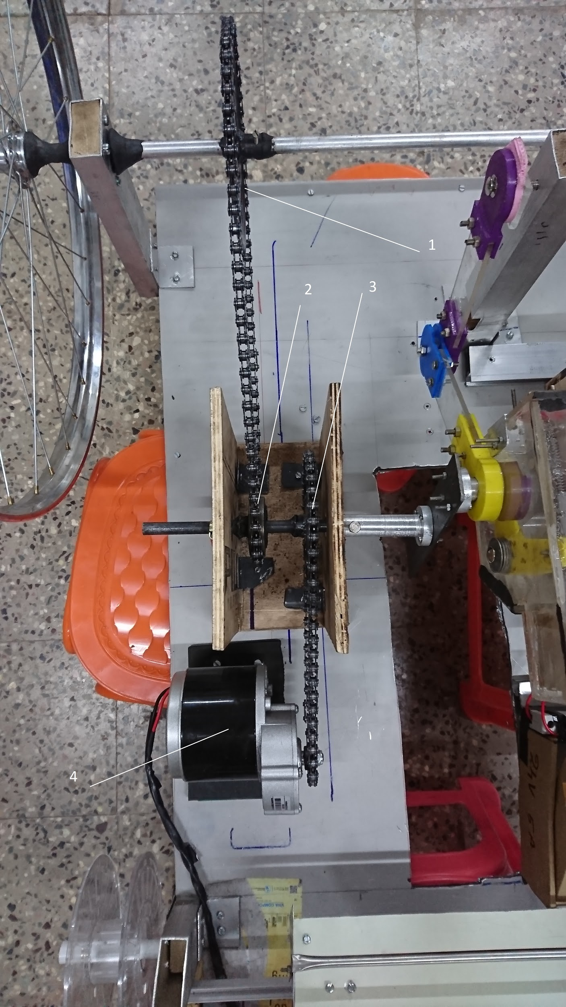

1: 40 teeth Gear, 2: 16 teeth Gear, 3: 32 teeth Gear, 4: Motor

**Engineering Details:**

The body is composed of an aluminum composite sheet placed over an aluminum framework.

The wheels are actually bicycle tire rims and all the connecting chains are also taken from bicycles.

The battery casing and the gearbox are made out of plywood.

The transplanting arm is composed of a mixture of acrylic pieces and various 3D printed parts.

**Electronics used:**

We have used a 350w, 300 rpm dc motor to power the main axle and transplanting mechanism.

1. A nema 17 stepper motor(torque of 6 kg-cm ) is used to bring about the side to side motion of the tray.

2. 2 arduino uno microcontrollers are used to control the motion of the dc motor and the nema stepper motor respectively.

3. The sabertooth motor driver( 24v, 35A) is used to control the dc motor and also regulate its voltage a well as current.

4. The nema 17 stepper motor is controlled with the help a stepper motor driver(A4988) which controls the current and precision of the stepper motor.

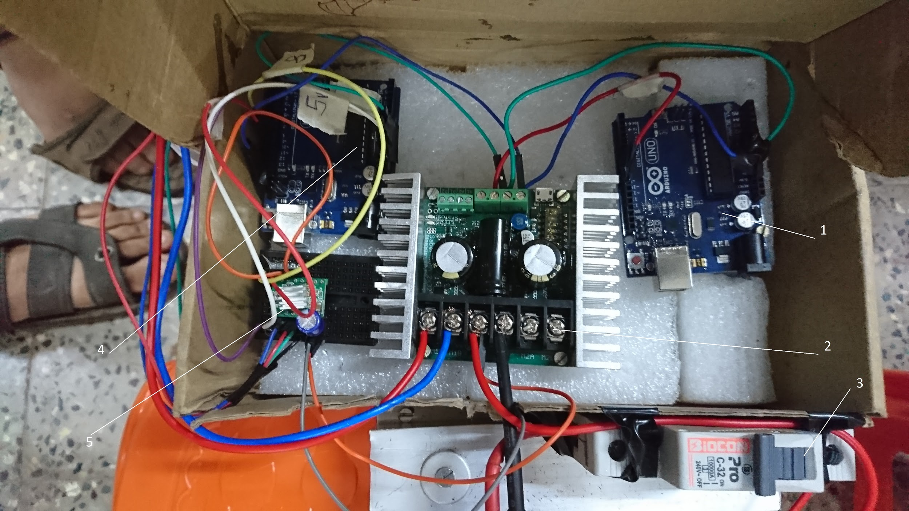

1: Arduino for Motor, 2: Sabertooth , 3: MCB Switch, 4: Arduino for NEMA 17, 5: A4988

**Calculations:**

Sprockets and their position No.of teeth

Motor Shaft 9

Gearbox Gear 1 32

Gearbox Gear 2 16

Wheel Shaft 40

Gear Ratio Reduction = (40/16)*(32/9) = 8.89

Max RPM of Motor = 300 RPM

Max RPM of Gearbox Shaft = 300*(9/32) = 85 RPM

Max RPM of Wheel Shaft = 300*(9/32)*(16/40) = 85*(16/40) = 34 RPM

RPM of Motor being used = 192 RPM

Accordingly, RPM of Gearbox Shaft obtained = 192*(9/32) = 54 RPM

RPM of Wheel Shaft obtained = 192*(9/32)*(16/40) = 54*(16/40) = 22 RPM

**Cost Analysis:**

|  |  |
| --- | --- |
| Main Motor(350W,20A) | Rs.4567/- |
| Sabertooth Motor Driver | Rs.9400/- |
| Stepper Motor Driver A4988 | Rs.175/- |
| UNO Arduino | Rs.800/- |
| Li Ion Battery | Rs.14800/- |
| Lead Screw | Rs.500/- |
| Composite Aluminum, Aluminum Sheet Metal, Iron/Aluminum Rods | Rs.2300/- |
| Cycle Rims | Rs.620/- |
| Ball Bearings (6001 R2H) | Rs.480/- |
| PLA (3D printing): | Rs500/- |
| Gears | Rs.250/- |
| Chain | Rs.250/- |

**Locus of Picking Fork:**

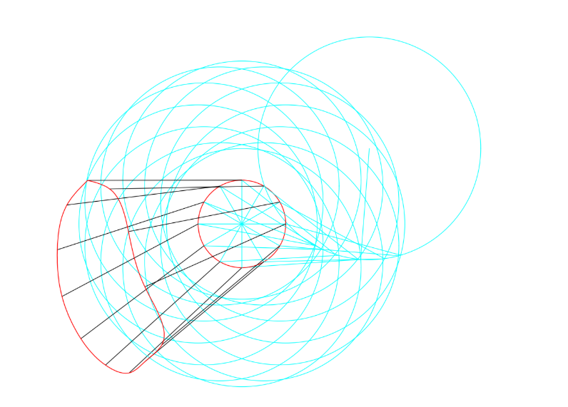

**Final Prototype:**

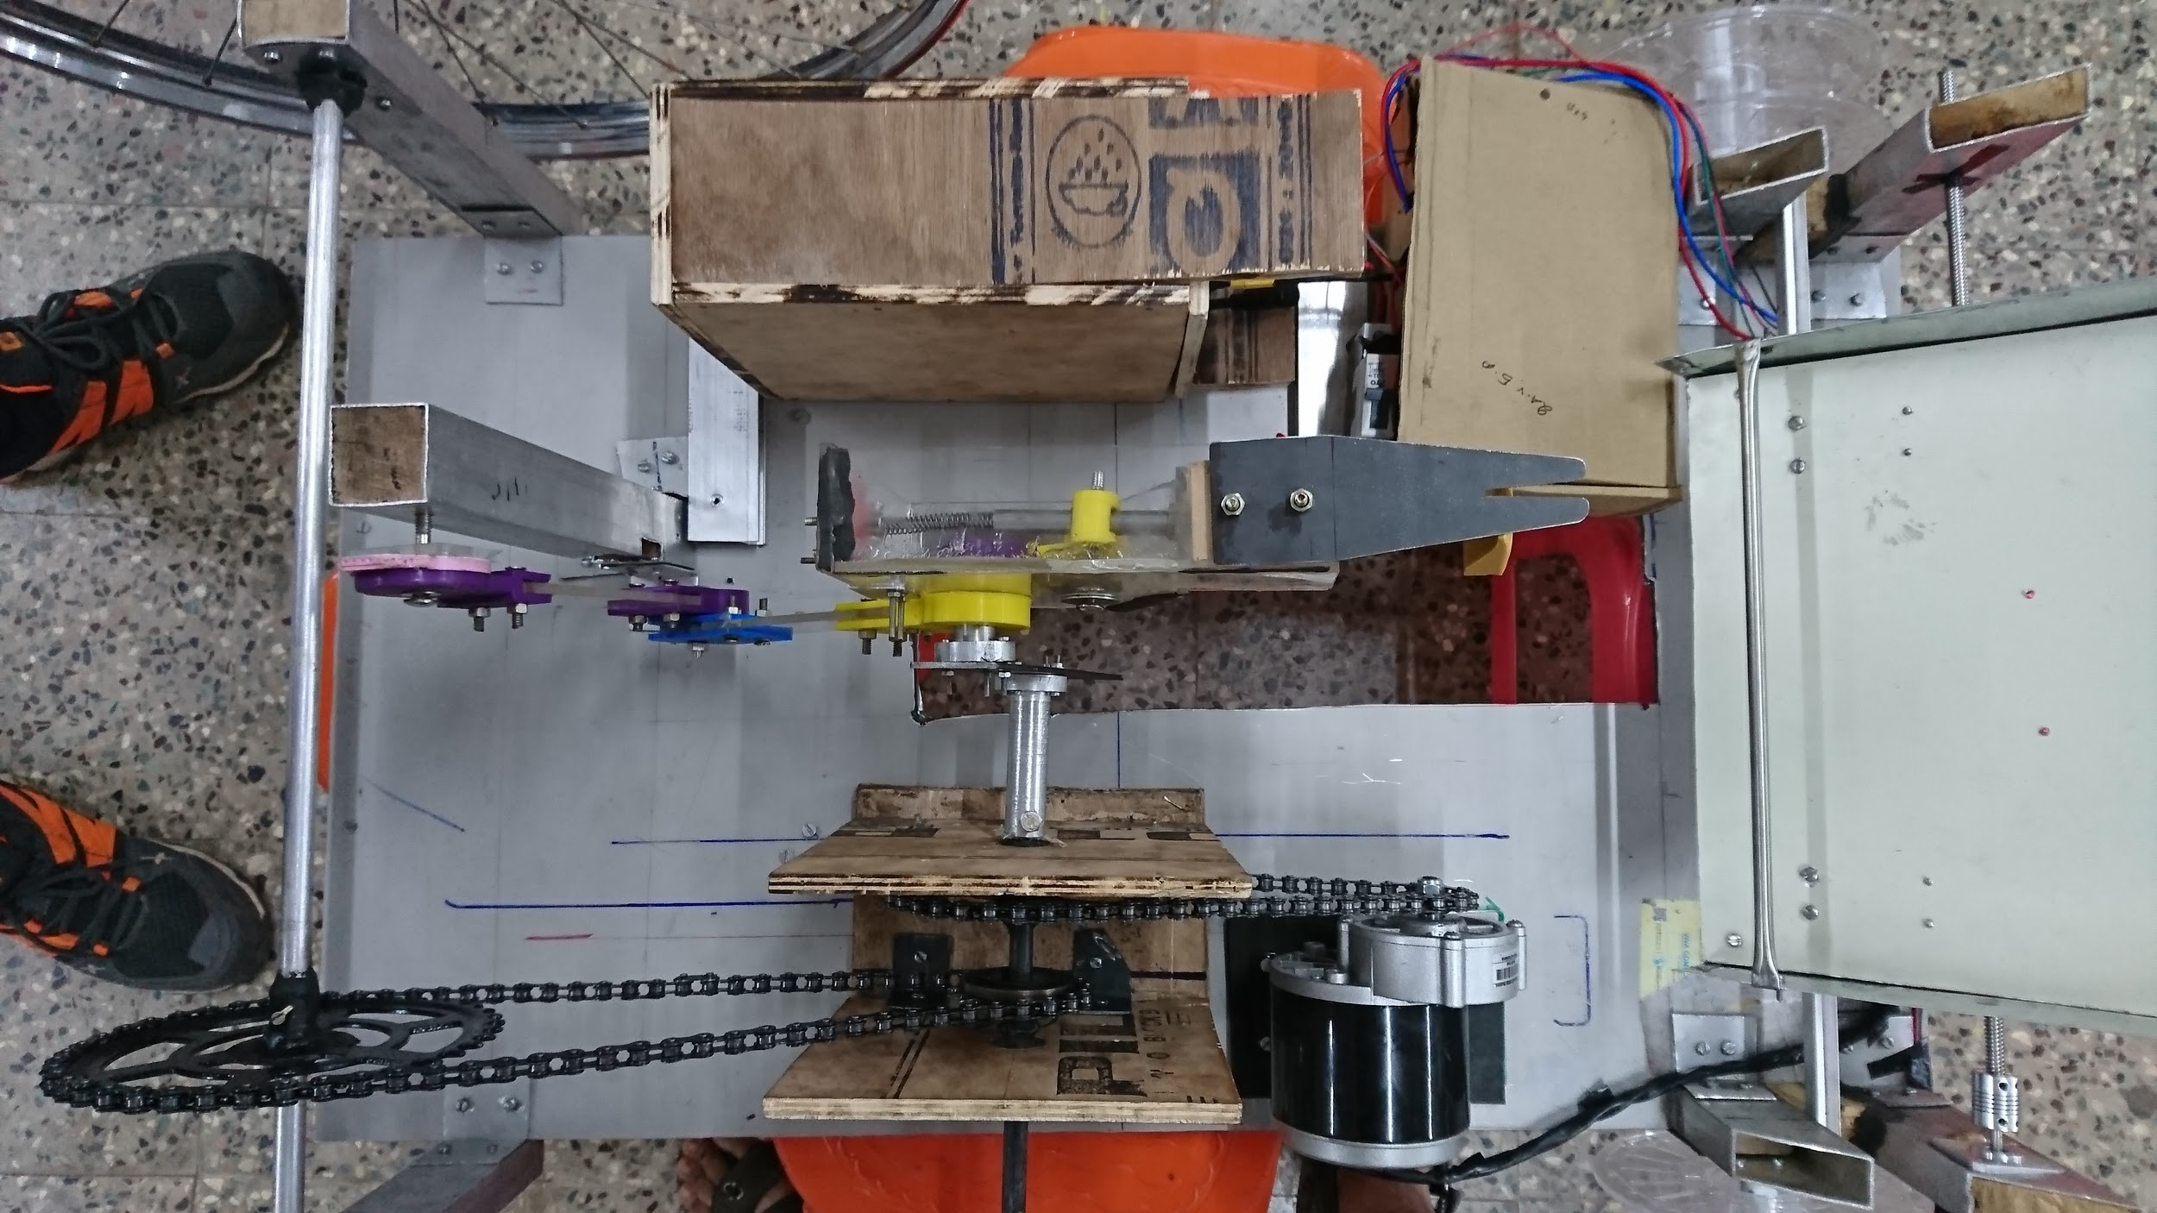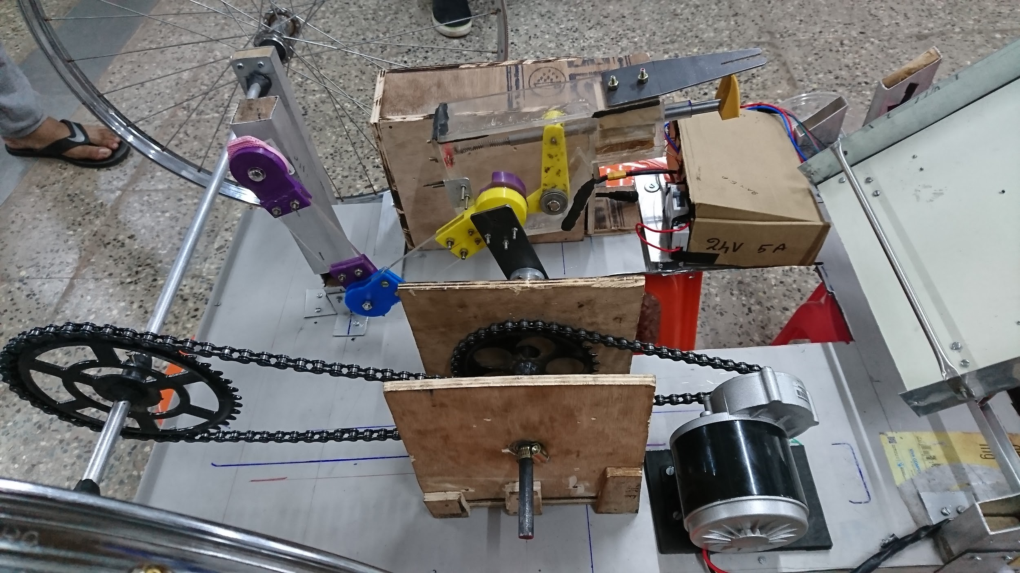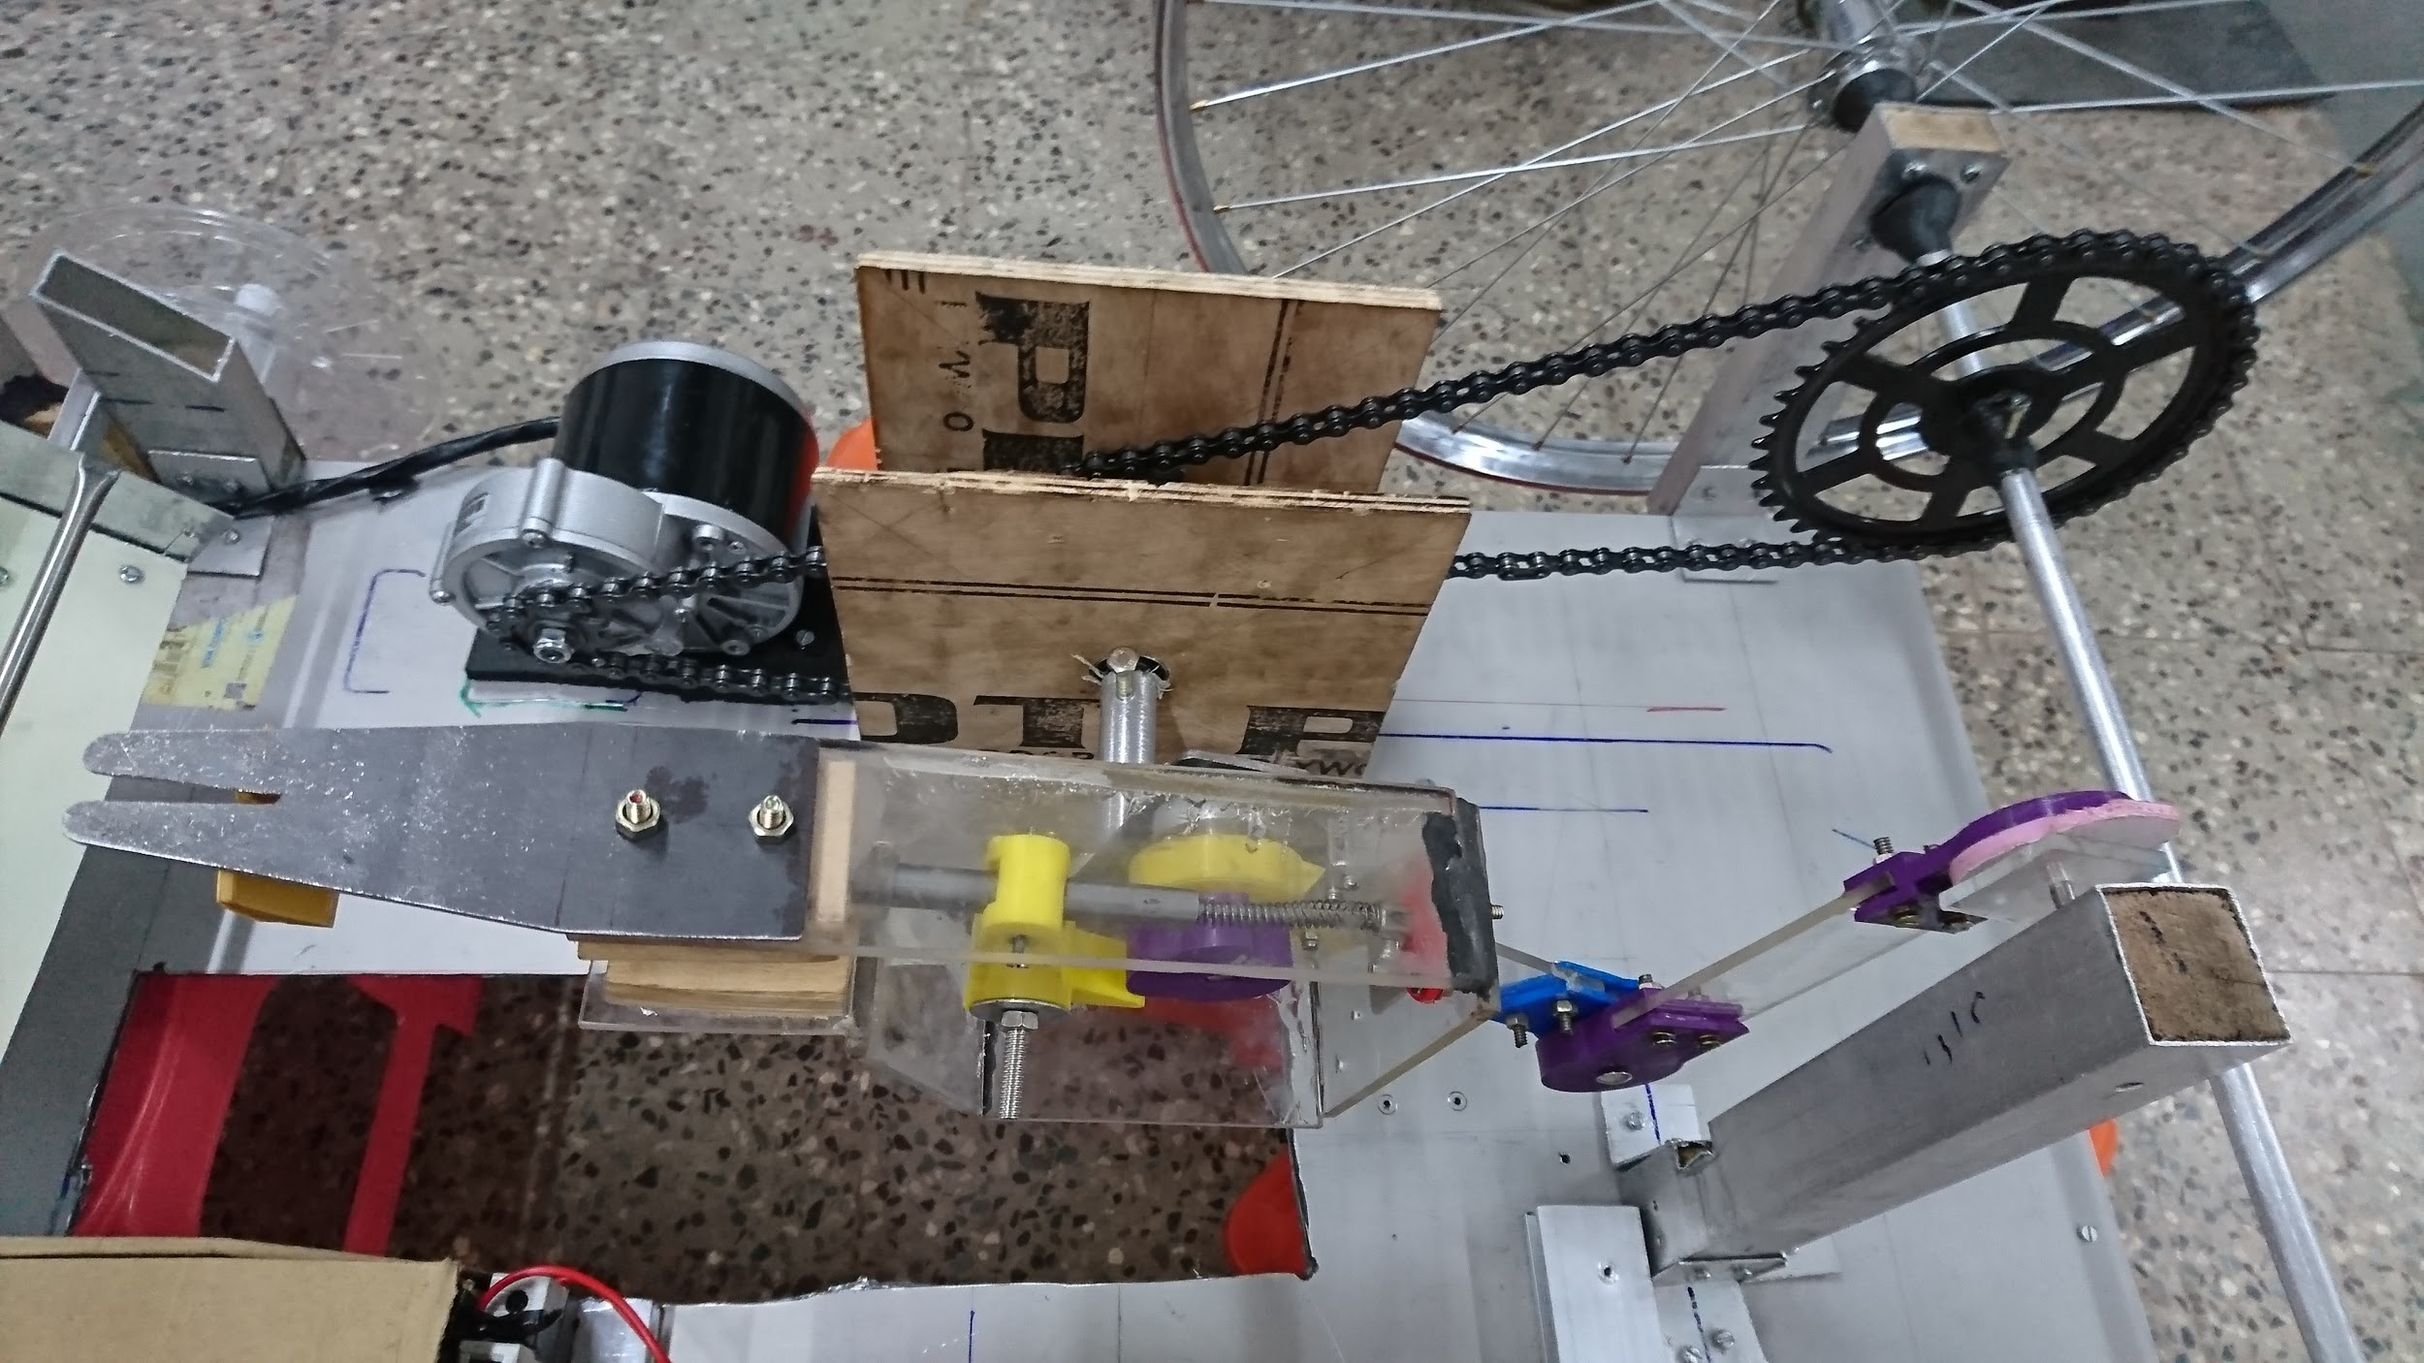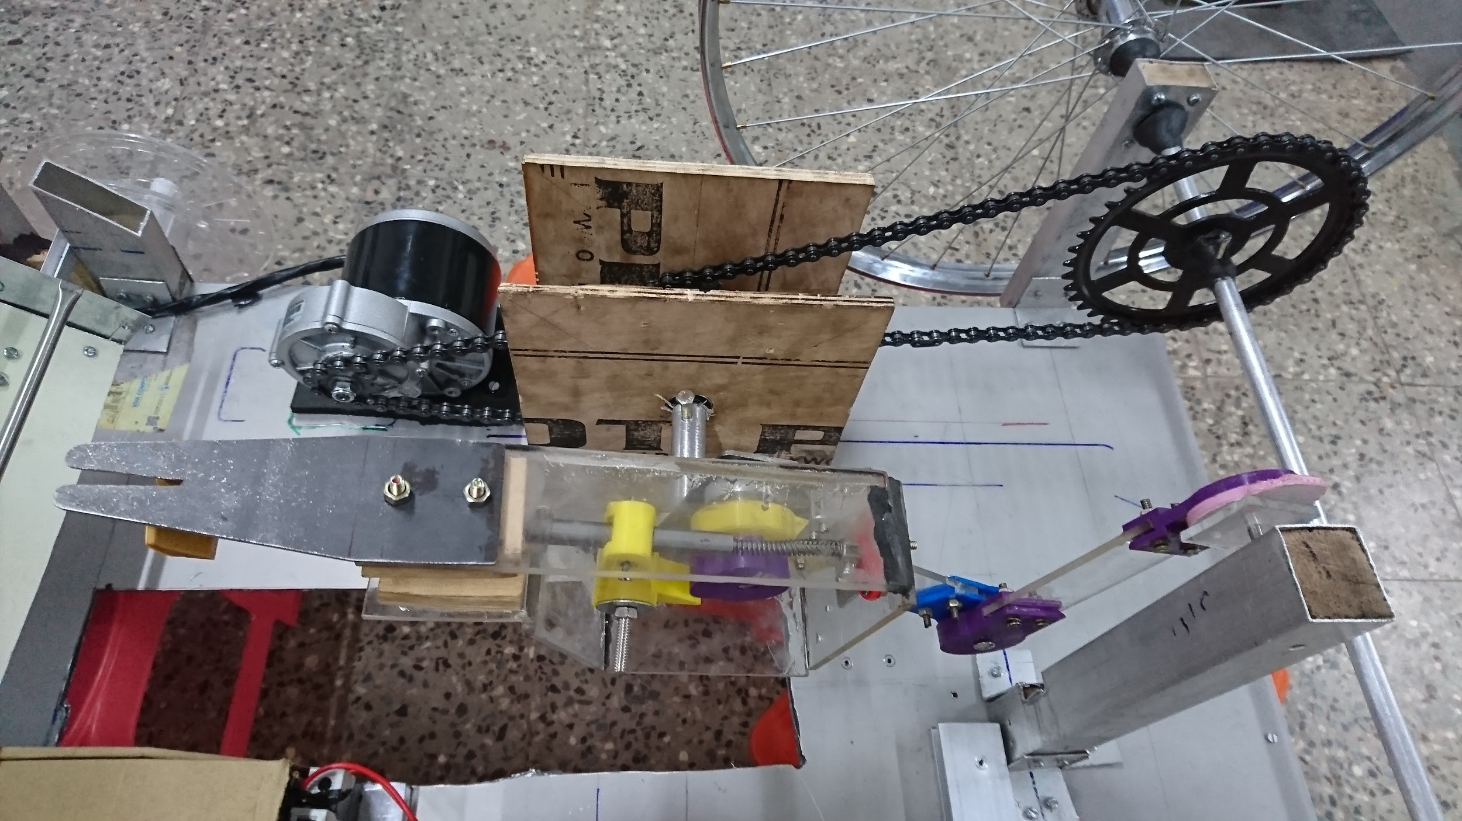

**Conclusion:**

We firmly believe that our design can be improved upon. We plan to add a steering system to our machine coupled with an autonomous guidance system to further automate the tedious task of transplanting rice. We also plan to make it possible to preset the transplanting distance on our machine by adding a more advanced gearbox. Moreover, we have tried to create our transplanting mechanism at the lowest possible cost. As you can see from the cost analysis, the cost of our machine minus the electronic components is only about Rs.4900/-. Thus, our mechanism is much more cost effective than existing systems while also being easy to repair and robust. Hence we believe that our creation can have a positive impact on the lives of rice farmers in our country.